1. Raw production materials are appearing in the sales product list.

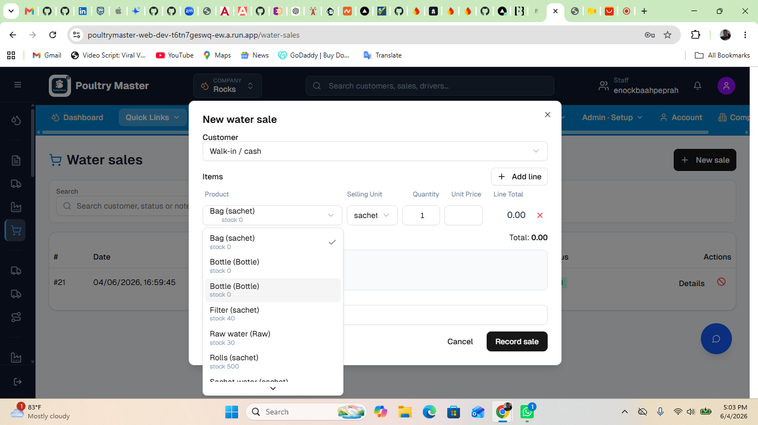

2. Issue 1: OTP is not received after clicking Send OTP
Issue 2: No error or success message is shown after submission
Issue 3: UI shows unexpected behavior (duplicate email input field appears)
